**SMART SENSOR ATTENDANCE SYSTEM IN TERTIARY INSTITUTIONS IN NIGERIA USING INTERNET OF THINGS (IoT) AND MOBILE APPLICATION.**

**BY**

**OSO DANIEL OLUWANIFEMI**

**18/67AM/00237**

**&**

**ADEFEMIWA DAMILARE QUADRY**

**20D/47CS/01228**

**AUGUST 2023.**

# 

**KWARA STATE UNIVERSITY, MALETE.**

**FACULTY OF INFORMATION AND COMMUNICATION TECHNOLOGY.**

**SMART SENSOR ATTENDANCE SYSTEM IN TERTIARY INSTITUTIONS IN NIGERIA USING INTERNET OF THINGS (IoT) AND MOBILE APPLICATION.**

**BY**

**OSO DANIEL OLUWANIFEMI**

**18/67AM/00237**

**&**

**ADEFEMIWA DAMILARE QUADRY**

**20D/47CS/01228**

**A RESEARCH PROJECT SUBMITTED TO THE DEPARTMENT OF COMPUTER SCIENCE, KWARA STATE UNIVERSITY, MALETE, IN PARTIAL FULFILLMENT OF THE REQUIREMENTS FOR THE AWARD OF BACHELOR OF SCIENCES (B. Sc) DEGREE IN COMPUTER SCIENCE.**

**JULY 2023.**

# 

# 

# 

# DECLARATION

I hereby declare that this research project titled, “**SMART SENSOR ATTENDANCE SYSTEM IN TERTIARY INSTITUTIONS IN NIGERIA USING INTERNET OF THINGS AND MOBILE APPLICATION**” is my own work and has not been submitted by any other person for any degree or qualification at any higher institution. I also declare that the information provided therein is mine, and those that are not mine are properly acknowledged.

Oso Daniel Oluwanifemi **_________________________**

**NAME OF STUDENT SIGNATURE AND DATE**

**_________________________ _________________________**

**NAME OF STUDENT SIGNATURE AND DATE**

**CERTIFICATION**

This is to certify that the research project titled “**SMART SENSOR ATTENDANCE SYSTEM IN TERTIARY INSTITUTIONS IN NIGERIA USING INTERNET OF THINGS AND MOBILE APPLICATION**” was carried out by “**OSO DANIEL OLUWANIFEMI**”. The project has been read and approved as meeting the requirements for the award of Bachelor of Sciences (B.Sc.) Degree in the Department of Computer Science, Faculty of Information and Communication Technology, Kwara State University, Malete.

**…………………………… ……………………………**

**DR. A.N. BABATUNDE DATE**

**(SUPERVISOR)**

**…………………………… ……………………………**

**DR. (MRS) R.S. BABATUNDE. DATE**

**(HEAD OF DEPARTMENT)**

**…………………………… ……………………………**

**EXTERNAL SUPERVISOR DATE**

**DEDICATION**

This Project report is dedicated to our Almighty God and to our beloved parents for their spiritual and financial support.

**ACKNOWLEDGEMENT**

We wish to express our profound gratitude to God Almighty for his guidance and presence throughout our existence. We are also grateful for our project supervisor, Dr. A.N. Babatunde, for his effort, fatherly attention and tireless corrections throughout the course of this research work,

We cannot but acknowledge our Head of Department, Dr. (Mrs) R.S. Babatunde, our level adviser, Dr. Akeem Kadri and all the amazing lecturers in the department of computer science in persons of Dr R.M. Isiaka, Dr. S.O. Abdulsalam, Mrs S.R. Yusuff, Mrs B.F. Balogun and Prof. K.A. Gbolagade for their continual dedication to our education.

We sincerely thank our parents for their moral, financial, and spiritual support throughout our education at Kwara State University.

Finally, we are grateful to everyone who has supported us in this phase of our lives. May God bless you all.

**TABLE OF CONTENTS.**

**FRONT PAGE…………………………………………………………………….. I**

**TITLE PAGE……………………………………………………………………… II**

**DECLARATION………………………………………………………………… III**

**CERTIFICATION………………………………………………………………. IV**

**DEDICATION…………………………………………………………………… V**

**ACKNOWLEDGEMENTS…………………………………………………….. VI**

**TABLE OF CONTENTS……………………………………………………… VII**

**LIST OF TABLES……………………………………………………………. VIII**

**LIST OF FIGURES……………………………………………………………. IX**

**ABSTRACT…………………………………………………………………….. X**

**CHAPTER ONE: INTRODUCTION……………………………………………. 1**

**1.1 BACKGROUND OF THE STUDY…………………………….**

**1.2 PROBLEM STATEMENT……………………………………..**

**1.3.1 AIMS OF THE STUDY………………………………………**

**1.3.2 OBJECTIVES AND RESEARCH QUESTIONS…………….**

**1.4 SCOPE OF THE STUDY………………………………………**

**1.5 SIGNIFICANCE OF THE STUDY……………………………**

**CHAPTER TWO: LITERATURE REVIEW………………………………….. ?**

**2.1 OVERVIEW OF ATTENDANCE SYSTEMS IN NIGERIA……**

**2.2 EVOLUTION OF SAAS……………………………………….**

**2.3 QUALITIES AND CREDIBILITY OF A SSAS………………**

**2.4 CHALLENGES AND LIMITATIONS OF SSAS…………….**

**CHAPTER THREE: RESEARCH METHODOLOGY…………………….. ?**

**CHAPTER FOUR: IMPLEMENTATION AND SYSTEM DESIGN……… ?**

**4.1 BLUETOOTH BEACON SETUP……………………………**

**4.2 MOBILE APPLICATION DEVELOPMENT…………..**

**4.3 PROXIMITY BASED ALGORITHM……………………**

**4.4 FIREBASE INTEGRATION…………………………..**

**4.5 TESTING AND VALIDATION.**

**4.6 DETAILED DESCRIPTION OF THE DEVELOPED SYSTEM.**

**4.7 CHALLENGES FACED DURING IMPLEMENTATION AND THEIR SOLUTIONS.**

**CHAPTER FIVE: SUMMARY AND CONCLUSION…………………… ?**

**5.1 SUMMARY OF PROJECT OBJECTIVES AND KEY FINDINGS.**

**5.2 CONTRIBUTIONS TO THE FIELD OF STUDY**

**REFERENCES**

**APPENDICES**

**ABSTRACT**

Student attendance in class is crucial, due to its effect on students' academic achievement. Monitoring student attendance is important because many colleges have minimum attendance requirements that must be met before students are permitted to take exams. Roll-call and sign-in procedures are traditional ways of keeping track of students' presence in the classroom, but they waste valuable instructional time and add to teachers' workloads. In this paper, we propose a Smart Sensor Attendance System based on Bluetooth Low Energy for autonomously tracking student attendance in classes. Three key elements are implemented into the design, and they work together to provide a smooth user experience. The system is made easy and cheap to use by using basic beacons, which is the crucial component. They can be used in pairing with a web service and mobile platform to track attendance in various ways.

**CHAPTER ONE**

**INTRODUCTION.**

**1.1 BACKGROUND TO THE STUDY**

Student classroom attendance is an important component of college education administration, which calls for the creation of methods and processes to assess the efficacy and logic of everyday teaching using actual, scientific data. Hu, J (2019). Attendance tracking is a fundamental aspect of educational institutions, ensuring accurate record-keeping and monitoring of student participation. According to H. Yang and X. Han, (2020), the traditional classroom attendance technique cannot satisfy the needs of students, professors, or the expansion of computer technology in colleges and universities. Traditional methods of manual attendance taking, such as paper-based systems or sign-in sheets, are often time-consuming, error-prone, and lack real-time monitoring capabilities. It also needs to repeatedly test the attendance information, which consumes a lot of manpower and materials. Zhou R. and Ji J. (2021). As technology continues to advance, there is a growing need for innovative solutions that streamline and automate the attendance tracking process.

Bluetooth beacons are small, wireless devices that emit Bluetooth signals, which can be detected by nearby mobile devices. According to Banani S. et al. (2021), Beacons and BLE technologies can be used as gateways for sending processed sensor data from Internet of Things systems. A useful connection between IoT devices and the cloud may be made possible through this, enabling data processing and real-time monitoring. Pcukdeevongs A. (2020), made it known that by leveraging Bluetooth technology, a mobile app can interact with these beacons to track the proximity of students and mark attendance based on their presence within a defined range. In recent years, Bluetooth beacon technology has emerged as a promising solution for proximity-based systems, offering the potential to revolutionize attendance tracking in schools. Student classroom attendance is an important component of college education administration, which calls for the creation of methods and processes to assess the efficacy and logic of everyday teaching using actual, scientific data. Studies by Wu et al. (2017, 2018), Wu and Zheng (2019), Li et al. (2019), and Kwon et al. (2020) have demonstrated the effectiveness of attendance management systems using Bluetooth beacon technology in various settings, including classrooms and large-scale lecture halls. These systems utilize Bluetooth beacon technology to automate attendance management, providing real-time attendance data that streamlines administrative processes and provides administrators with accurate, reliable data for decision-making.

Furthermore, the advent of mobile app development frameworks, such as Flutter, has provided opportunities for building cross-platform applications with enhanced functionality and user experience. Flutter offers a robust framework for developing mobile apps that can run seamlessly on both iOS and Android platforms, reducing development time and effort.

Firebase, a cloud-based platform developed by Google, provides a comprehensive suite of backend services that can be leveraged for developing scalable and secure applications. With Firebase, developers can easily integrate features like real-time data synchronization, user authentication, and cloud storage into their apps, eliminating the need for complex server management.

Given the potential benefits of Bluetooth beacon technology, mobile app development frameworks, and cloud-based backend solutions, this project aims to leverage these technologies to create a smart sensor attendance system for schools. By incorporating Bluetooth beacons, a mobile app built with Flutter, and Firebase as the backend infrastructure, the project seeks to automate and streamline the attendance tracking process, improving accuracy, efficiency, and real-time monitoring capabilities.

Through this study, the potential of Bluetooth beacon technology, mobile app development frameworks, and cloud-based backend solutions will be explored in the context of attendance tracking systems. The findings of this research will contribute to the existing body of knowledge on proximity-based attendance tracking and provide insights into the effectiveness, usability, and feasibility of implementing such a system in educational institutions.

Overall, this study aims to bridge the gap between traditional attendance tracking methods and modern technological advancements, offering a practical and efficient solution that improves the accuracy and efficiency of attendance management in schools.

**1.2 PROBLEM STATEMENT**

**1.2.1 INTRODUCTION.**

A crucial component of many different industries, such as education, corporate settings, and events, is attendance management. Modern requirements for attendance tracking have proven to be too demanding for conventional systems to handle. IoT technologies' introduction has paved the way for cutting-edge solutions that can automate and improve attendance management procedures. One such technology is Bluetooth beacon technology, which is popular because it enables smooth interactions between devices and may deliver precise location-based information.

According to Karwan Jackson et al. (2018), the traditional methods of manual attendance tracking in educational institutions are time-consuming, prone to errors, and lack real-time monitoring capabilities. Using paper-based registers or biometric systems for manual attendance registration not only takes up valuable time but also leaves the possibility for fraud and mistakes. A contemporary and intelligent attendance system is clearly needed as businesses and educational institutions work to optimize operations and improve data accuracy. The reliance on paper-based systems or sign-in sheets often leads to inefficiencies, inaccuracies, and a significant administrative burden. Additionally, these methods do not provide real-time insights into student attendance, making it difficult for lecturers and administrators to track participation effectively.

Furthermore, the limitations of traditional attendance tracking methods hinder the ability to efficiently manage attendance records, analyze attendance patterns, and promptly address issues related to student engagement. The lack of real-time monitoring and accurate attendance data makes it challenging for educational institutions to ensure accountability, identify trends, and implement effective interventions to improve student attendance rates.

Additionally, as educational institutions continue to grow and expand, the scalability and efficiency of attendance tracking become crucial concerns. Traditional methods struggle to accommodate increasing student populations, leading to further administrative challenges and potential inaccuracies in attendance records.

Therefore, there is a need for an innovative solution that automates and streamlines the attendance tracking process, overcoming the limitations of manual methods. This solution should offer real-time monitoring, accurate attendance marking, secure data storage, and easy access to attendance records for both lecturers and students. The solution should also be scalable to adapt to the varying needs of educational institutions, facilitating efficient attendance management and improving student engagement.

Addressing these challenges will provide educational institutions with a reliable, efficient, and technologically advanced attendance tracking system. Such a system would enable lecturers and administrators to have real-time insights into student attendance, simplify attendance management processes, and promote student accountability. By automating attendance tracking, the solution will free up valuable time and resources, allowing educators to focus on more impactful teaching and mentoring activities.

**1.2.2 MOTIVATION.**

As demonstrated by recent studies like Jeon, K. E. (2018), Spachos, P. (2020), and Gómez-de-Gabriel, J. M. (2022), the potential of BLE beacons for allowing creative IoT applications is now being explored.

Therefore, we have to develop a smart sensor attendance system that utilizes Bluetooth beacon technology, a mobile app built with Flutter, and a cloud-based backend infrastructure like Firebase to address the limitations of traditional attendance tracking methods. The goal is to create an innovative and scalable solution that improves the accuracy, efficiency, and real-time monitoring capabilities of attendance management in educational institutions.

**1.2.3 RELATED WORKS AND THE PROBLEMS FACED.**

An attendance system was created and put into use by Dhiman Sarkar et al. (2016) using multi-step authentication. In Bangladesh's conventional attendance system, teachers either call a student's name or identification number, to which the student responds, or they present the student with an attendance sheet for them to sign. The challenges in system administration have significantly increased over the past two decades as student enrollment has expanded. Once more, when the attendance form is handed to the pupils, some sign it more than once, and proxy attendance is recorded. These two systems are very time-consuming. To overcome these inconveniences, this paper represents a smart attendance system. Priya Pasumarti et al. (2018) present in their paper a face recognition system for attendance. Attendance for the students is an important task in class. When done manually, it generally wastes a lot of productive time in the class. This proposed solution for the current problem involves the automation of the attendance system using face recognition. The Face is the primary form of identification for any human.

**1.3 AIM AND OBJECTIVES**

The aim of the project is to develop a smart sensor attendance system using Internet of Things and a mobile application for tertiary institutions in Nigeria

To achieve this goal, the project has the following objectives:

1. Design and Development of the Mobile App:

- Develop a user-friendly mobile app using the Flutter framework, catering to the needs of both lecturers and students.

- Create separate interfaces for lecturers and students, enabling them to perform attendance-related tasks efficiently.

- Implement intuitive and interactive user interfaces for attendance marking, attendance history viewing, and class management.

2. Integration of Bluetooth Beacon Technology:

- Integrate Bluetooth beacon technology, specifically the NRF51822 model, with the mobile app for proximity-based attendance tracking.

- Establish communication between the mobile app and Bluetooth beacons to detect and monitor student presence within defined proximity ranges.

- Retrieve the received signal strength indicator (RSSI) values from the Bluetooth beacons and utilize them for distance estimation calculations.

3. Implementation of Proximity-Based Algorithm:

- Implement a proximity-based algorithm utilizing the log-distance path loss formula to estimate the distance between the student's mobile device and the Bluetooth beacon.

- Calibrate the algorithm parameters to improve accuracy and account for environmental factors.

- Mark attendance based on the proximity of the student's device to the Bluetooth beacon within the defined range.

4. Integration with Firebase Backend:

- Integrate Firebase as the cloud-based backend infrastructure for secure data storage and synchronization.

- Utilize Firebase Authentication to ensure secure user login and access control for lecturers and students.

- Store attendance records and relevant information in Firebase Realtime Database or Firestore, allowing real-time synchronization and easy retrieval.

5. Testing, Validation, and Performance Evaluation:

- Conduct comprehensive testing of the developed system to ensure accurate proximity-based attendance marking and reliable data synchronization.

- Validate the system's performance by simulating various scenarios and assessing its accuracy, responsiveness, and usability.

- Evaluate the system's performance against predefined metrics, such as attendance accuracy, system responsiveness, and user satisfaction.

6. Documentation and Reporting:

- Document the system architecture, design decisions, and implementation details for future reference.

- Prepare comprehensive reports detailing the project's objectives, methodology, findings, and recommendations.

- Provide clear and concise documentation for the developed system, including user manuals and technical guides.

By achieving these aims and objectives, the project aims to contribute to the field of attendance tracking systems by providing a reliable, efficient, and technologically advanced solution. The developed smart sensor attendance system will streamline attendance management processes, improve accuracy, and enable real-time monitoring of student attendance, ultimately enhancing the educational environment and promoting student engagement.

**1.4 SIGNIFICANCE OF THE STUDY.**

The implementation of a smart sensor attendance system using beacons in educational institutions brings several significant advantages that enhance efficiency, accuracy, and engagement. Some key significance of the smart sensor attendance system using beacons include;

1. Enhanced Accuracy and Automation: Manual attendance taking is labor-intensive and prone to mistakes. Beacons are used in a smart sensor attendance system that automates the process and gets rid of human mistakes. According to A. M. Suganthi et al. (2018), The use of beacons for attendance has been proven to dramatically minimize errors and save time when compared to traditional techniques.
2. Real-time Tracking: Ankit et al. (2017), discussed the real-time tracking capabilities of BLE beacons in attendance systems. Real-time attendance tracking is made possible by beacons, allowing educators and administrators to monitor student presence as soon as possible.
3. Enhanced Engagement: The convenience of using mobile devices and technology-driven attendance systems can engage students more effectively. A study conducted by Hafiz Adnan Habib et al. (2019) highlights the engagement benefits of using technology for attendance management.
4. Analytics and Reporting of Data: Smart sensor attendance systems produce data that can be utilized for in-depth research and reporting to provide insight into trends in attendance. According to Saumya Goyal et al. (2019), data analytics are important for enhancing attendance management.
5. Adaptation to Different Environments: The beacon-based attendance system is adaptable to a variety of educational environments, including workshops and seminars as well as classrooms. The adaptability of such systems is highlighted in a study by Satish Narayana Srirama et al. (2018).

The implementation of a smart sensor attendance system using beacons in educational institutions addresses a number of problems with conventional attendance procedures. The above significance highlights how important the increased accuracy, engagement, and administrative effectiveness that such technologies provide.

**1.5 SCOPE AND LIMITATIONS OF SMART SENSOR ATTENDANCE SYSTEMS.**

The smart sensor attendance system has gained popularity in educational sectors due to its efficiency and consistency in tracking students attendance. However, there are scopes and limitations associated with its implementation.

Scope:

1. Efficiency: By automating the procedure, these solutions help simplify attendance management. There is no longer a requirement for manual record-keeping as soon as students or staff reach the range of the beacon. Riya Lodha et al. (2015)
2. Accurate Attendance Tracking: Smart sensor attendance systems use advanced technology such as RFID, biometrics, and facial recognition to accurately record students' attendance. According to Bhavana D. et al. (2020), this eliminates the chances of proxy attendance and ensures that only the registered students are marked present.
3. Integration: These systems are capable of integrating with other technologies, such as management software or mobile apps. The whole user experience is improved by integration, which can also offer extra services like notifications or data analysis. Dedy, R. W., and Ibnu Asror (2015).
4. Real-time Information: According to Lia Kamelia et al. (2018), beacons and smart sensors can provide real-time attendance information. Administrators now have immediate access to attendance data, allowing for quick interventions or decisions.

Limitations:

Due to its effectiveness and consistency in tracking students' attendance, the smart sensor attendance system has grown in favor in the educational field. But its limitations related to its application will be discussed below.

Absolute positioning with BLE beacons is typically ineffective when GPS signals are not available. Relative positioning that is based on proximity is still incredibly valuable. A potential application in this area is motion detection using accelerometers, for example. Machine learning signal analysis is particularly well suited for mobile beacons in order to assess motion detection by proximity. As a method for this kind of evaluation, signal analysis is also quite pertinent.

BLE beacons are more common because of their low energy consumption and use of the 2.4 GHz band. According to Pei L. et al. (2017), AFH (Adaptive Frequency Hopping) technology is used to assure compatibility with other WiFi transmissions. In particular, BLE uses channels 37 to 39 when in beacon mode to reduce interference from other wireless signals. Regardless of the profile, the Received Signal Strength (RSS) parameter, which provides information on the received power (Pr) in relation to the transmit power at the receiver, is a critical component of the beacon protocol. The received signal strength indicator (RSSI) of radio frequency (RF) signals is frequently used to locate BLE beacons. A Bluetooth beacon signal can travel up to 150 meters; however, this distance can only be reached when there are no physical obstructions in the way of the signal's passage between the transmitter and the receiver. Pr can be used to calculate the distance between a beacon and a receiver in a clear line of sight situation because it is inversely proportional to the square of the distance. However, changes in the receiver's measurement sensitivity (RSSI), particularly when several beacons are close to one another, may have an impact on the precision of the reported distance.

BLE strategically uses only 40 of the 79 channels allotted to Bluetooth, spaced evenly at 2 MHz in the 2.4 GHz ISM band, preventing its transmissions from interfering with the 14 Wi-Fi channels. However, restricting scanning to a brief timeframe may result in a smartphone missing some beacon signals in a setting where beacons are dispersed randomly. Even when the beacons are immobile, experimental testing by Jeon, K. E., et al. (2018) showed that the RSS signal from several beacons can vary significantly over time. Each beacon can be detected in less than a second under ideal circumstances, but under unfavorable circumstances, the detection time can surpass five seconds because of environmental factors such as relative motion and signal propagation.

**1.6 DEFINITION OF TERMS**

Bluetooth Beacon- is a small wireless device that transmits data and signals to the nearest Bluetooth-enabled devices, such as smartphones, tablets, or other devices, using Bluetooth Low Energy (BLE) technology.

Internet of Things- refers to a network of physically interconnected objects, including furniture, machinery, vehicles, buildings, and other things, that use sensors, software, and other technologies to gather and exchange data online.

Bluetooth Low Energy- sometimes referred to as Bluetooth Smart, is a wireless communication technology created for short-range, low-power communication between devices.

Flutter- is an open-source UI (User Interface) software development toolkit created by Google.

Firebase- Firebase is a set of cloud-based development tools that help mobile app developers build, deploy, and scale their apps.

Proximity- refers to the state of being near or close to something in terms of physical distance or location  
RFID- stands for Radio Frequency Identification. It is a technology that uses radio waves to wirelessly identify and track objects, animals, or people

Attendance- refers to the act of being present at a specific location, event, or activity.

**CHAPTER TWO**

**LITERATURE REVIEW**

**2.1.**  **REVIEW OF ATTENDANCE SYSTEMS IN EDUCATIONAL INSTITUTIONS.**

Attendance systems have evolved over the years, with organizations and educational institutions adopting various methods to track attendance and ensure efficient workforce management. Student attendance during classroom hours is important, because it impacts the academic performance of students. According to a study by Stanca L. (2006) using a sizable dataset, there is a link between academic achievement and attendance in school. Additionally, Kumar, P.P. (2016) used Quantum Regression Analysis to illustrate the detrimental effect of absence from class on academic performance. Consequently, several universities impose a minimum attendance percentage criterion for students to be allowed to attend examinations; therefore, recording student attendance is a vital task. According to Puckdeevongs A. (2020), Conventional methods for recording student attendance in the classroom, such as roll-call and sign-in, are inefficient uses of instruction time and only increase teachers’ workloads.

We propose a Bluetooth Low Energy-based student positioning framework for

automatically recording student attendance in classrooms. The proposed architecture consists

of two components, an indoor positioning framework within the classroom and student attendance registration.

**2.2.** **EVOLUTION OF SMART SENSOR ATTENDANCE SYSTEMS.**

Smart sensor attendance systems have undergone significant evolution over the years, leveraging advancements in sensor technology, connectivity, and data processing. One of the areas of concentration and research in colleges and universities is the informatization and growth of educational management. Most educational institutions started with traditional attendance methods to maintain their attendance records.

Educational institutions adopted smart sensor attendance systems like BLE, RFID, and Biometrics because managing traditional attendance systems for multiple students at a time is a tedious task, and there is a very high probability of having fake attendance marked. Bluetooth is a wireless technology standard used to transfer data over short distances. It is also known as “Bluetooth Smart,” which is a subset of the classic lightweight Bluetooth class that has been introduced as part of the core Bluetooth 4.0 specification. A student attendance system based on Bluetooth and RFID was developed by Bhalla et al (2013). In this system, student information is first collected via an RFID reader, and the class assistant or professor can then view the student attendance by using a desktop or laptop connected to the system. Lodha et al. (2015) developed an attendance management system application for Bluetooth-enabled devices. Their system requires Bluetooth electronic tags that can be embedded into student ID cards. This system improves efficiency, as it can work with a wireless network while using Bluetooth technology, thereby removing the necessity for students to display their cards over a reader. Saraswat and Garg (2016) developed an application using beacons for faculty admin tasks. This system directly notifies and interacts with students via web links and an application. Moreover, during the class, students’ attendance information is automatically gathered by the system based on their location in the classroom. The system runs a clock timer (in the application background) when the student is close to the beacon (near and immediate). The computation in this system is primarily performed on the student’s smartphone. This requires a significant amount of processing on the student’s mobile phone. BLE aims to provide greatly reduced power consumption and cost while maintaining a similar communication range (Azmi et al., 2018).  Therefore, an Attendance Management System (AMS) and web-based application are needed to effectively manage student’s attendance and class schedules. Rjeib, (2018). incorporating a Bluetooth Low Energy-based student positioning framework for automatically recording student attendance in classrooms is proposed. (Puckdeevongs et al, 2020)

Beacons are small BLE radio transmitters that have given mobile applications the ability to understand position based on micro-local scales and provide proximity content to location-based receivers (Baharin et al., 2020). Beacon devices are placed in fixed locations (e.g., classrooms, lecture halls, etc.) or can be brought by the lecturer. Whenever there is a class, students’ smartphones can detect beacons, thus allowing attendance to be taken. The range of BLE devices can be adjusted; thus, the device can transmit, and it can be connected to an infinite number of devices or smartphones (Puckdeevongs et al., 2020). This device will be placed in the classroom, where students will check in to confirm their attendance via Bluetooth. Students will be able to verify their personal information via the mobile app, and lecturers will be able to easily observe the number of attendees for their classes and the information of participating students anytime and anywhere. Therefore, an Attendance Management System (AMS) and web-based application are needed to effectively manage student’s attendance and class schedules. Rjeib, (2018). incorporating a Bluetooth Low Energy-based student positioning framework for automatically recording student attendance in classrooms is proposed. (Puckdeevongs et al, 2020)

**2.3.** **QUALITIES AND CREDIBILITY OF SMART SENSOR ATTENDANCE SYSTEM USING BLE.**

A smart sensor attendance system that utilizes Bluetooth Low Energy (BLE) technology can be credible and reliable if implemented and maintained properly. The credibility and quality of a smart sensor attendance system using BLE depend on several factors, like;

* Accuracy: The system should accurately detect and record attendance data. BLE technology can provide reasonably accurate results, especially when combined with other sensors or methods such as geolocation or facial recognition. A Location-Based Attendance Management System Using Bluetooth Low Energy (BLE) Beacons, Wu et al. (2018) present a location-based attendance management system using Bluetooth Low Energy (BLE) Beacons. The study shows that the use of BLE beacons improves accuracy and reduces administrative workload.
* Security: A credible system should prioritize data security and privacy. BLE technology has built-in security features, including encryption and authentication protocols, which help protect data transmission between devices. It is essential to ensure that the system implements robust security measures to prevent unauthorized access or tampering with attendance data. Attendance Management System Based on Bluetooth Low Energy Technology, Wu and Zheng (2019) present a novel attendance management system using Bluetooth Low Energy Technology. The study shows that the system is secured, and the use of Bluetooth low energy technology also improves accuracy and reduces administrative workload.
* Reliability: The system's reliability is crucial for ensuring consistent attendance tracking. Factors such as sensor placement, signal range, and battery life of the BLE devices can impact the system's reliability. Adequate infrastructure planning and regular maintenance are necessary to maintain reliable connectivity and minimize system downtime. Smart Classroom Attendance System Based on Bluetooth Beacon Technology, Li et al. (2019) describe the design and implementation of a smart classroom attendance system using Bluetooth beacon technology. The study shows that the system is effective and reliable, and the use of Bluetooth beacon technology improves accuracy and reduces administrative workload.

To assess the credibility of a specific smart sensor attendance system using BLE, it is essential to evaluate the system's features, technical specifications, and any case studies or deployments in similar environments. Conducting a pilot test or seeking recommendations from other organizations using similar systems can also provide valuable insights into the system's credibility.

**2.4.** **CHALLENGES AND LIMITATIONS OF SMART SENSOR ATTENDANCE SYSTEMS**

Smart sensor attendance systems that use Bluetooth Low Energy (BLE) technology provide several advantages over conventional attendance systems, including improved accuracy, real-time monitoring, and easy mobile device integration. However, it also has some drawbacks and difficulties that must be considered.

* Connectivity Issues: BLE relies on wireless communication, and interference or obstacles can disrupt the signal strength and cause connectivity problems. This can result in attendance data not being transmitted accurately or consistently.
* Battery Life: BLE devices, such as beacons and tags, are commonly powered by batteries. Longer battery life is required to avoid frequent maintenance and replacement. However, if the batteries are not properly maintained and controlled, attendance devices might go inactive, resulting in incorrect attendance reports.
* Range Restrictions: When compared to regular Bluetooth, BLE has a restricted range, and the effective range can be reduced by a variety of variables such as physical obstacles and signal interference. If the attendance system depends on Bluetooth Low Energy beacons or tags, the placement and distribution of these devices around the region must be carefully studied to maintain consistent coverage.
* Security and Privacy Concerns: BLE transmissions can be vulnerable to unauthorized access or spoofing attacks if appropriate security measures are not implemented. Ensuring the security and privacy of attendance data is crucial, particularly when dealing with sensitive information.

**CHAPTER 3**

**RESEARCH METHODOLOGY**

**3.1 RESEARCH DESIGN**

The research design selected is an experimental iterative approach using agile development methods. This approach enables incrementally building and validating attendance system capabilities through rapid prototype iterations.

Key aspects of this experimental, agile research design are:

- Breaking down attendance system requirements into modular user stories and prioritizing based on value.

- Developing minimum viable prototypes in sprints to validate priority features early, like accuracy.

- Testing prototypes frequently with sample users to gather feedback on usability, engagement, etc.

- Using feedback to refine prototypes and add new capabilities in response to research objectives.

- Leveraging continuous integration to evolve the integrated system encompassing IoT, mobile, and backend.

- Focusing on end-to-end functionality over complex architectures to improve adaptability.

This research design enables an evidence-based, user-centric approach to iteratively building an attendance system that meets the outlined objectives. The agile, collaborative methodology values rapid learning over long development cycles and extensive documentation. The focus is on tangibly fulfilling the key goals through regular prototype demos and user validation. This empirical approach was chosen as it aligns with the research aims of developing an accurate, efficient, and user-friendly attendance system.

**3.2 FLUTTER DEVELOPMENT ENVIRONMENT AND TOOLS**

The mobile application for automated student attendance was built using Google's Flutter SDK, which enabled cross-platform development for both iOS and Android from a single Dart codebase.

The tools used in the building of the application with Flutter were an IDE (Visual Studio Code was selected) and a physical device, which was an Infinix x657B.

Visual Studio Code was chosen as the primary IDE for its excellent Flutter support via plugins like Dart Code. VS Code provided robust code editing, debugging, inline documentation, and version control - critical capabilities for efficient Flutter development.

For state management within the app, the Riverpod library was incorporated to provide a simple yet powerful reactive programming model. Riverpod's streamlined APIs helped manage state elegantly as the app's complexity grew.

To enable continuous integration and delivery, GitHub Actions was configured to build the app on every commit across multiple platforms and run tests. This automated the release pipeline, enabling rapid iterations.

During testing, real devices were used so it was known right away what features did not work right out of the box. Hot Reload allowed viewing UI changes in real-time, speeding up the development process.

**3.3 HARDWARE AND SOFTWARE REQUIREMENTS FOR BUILDING IOT BASED ATTENDANCE SYSTEM**

There are a couple of pieces of hardware and software needed for building the attendance system. They include the following:

**HARDWARE**:

- BLE beacons - Low energy Bluetooth transmitters to deploy across classrooms for proximity detection.

- Student devices - Smartphones or tablets with BLE capability and a mobile app installed.

- Computer System: For running Visual Studio in order to use the Flutter SDK to develop the application.

**SOFTWARE**:

- Cloud Storage – Firebase was used for the cloud storage through the firebase core and cloud Firestore packages. There was also a need to install a flutterfire application so as to connect the app to the firebase application created on the web app.

- Processing logic - Algorithms for processing beacon data and attendance calculations Can use cloud functions.

- Admin dashboards - Built with frontend stacks like React to provide teacher and admin interfaces.

- Notifications - Push notification services to inform students of attendance status or changes.

**3.4 PROCEDURES FOR SYSTEM DEVELOPMENT, TESTING AND VALIDATION**

**SYSTEM DEVELOPMENT PROCEDURES**

1. Software Development Methodology: An agile software development methodology was adopted to build the system iteratively.
2. Mobile Component: Flutter was used to implement the mobile components since it provided multiple features for application development.
3. Cloud Component: Firebase was used to implement the cloud storage of attendances. Firebase is a SaaS service created by Google to enforce its reliability.

**TESTING AND VALIDATION PROCEDURES**

1. Unit Testing: Testing of individual components, such as the mobile app's attendance recording logic or the backend's API endpoints, in isolation to ensure they function correctly.
2. Integration Testing: Testing the interaction between different components, such as the mobile app and beacons, to verify that data flows seamlessly between them.
3. System Testing: Test the entire system as a whole to ensure that all components work together cohesively. Verify attendance recording, data accuracy, and user interfaces.
4. Performance Validation: Validate that the system performs as expected in a real-world setting. Monitor response times, data synchronization, and overall system behavior.
5. Bug Fixes and Improvements: Address any issues, bugs, or user concerns identified during testing and validation. Make necessary refinements to enhance the system's functionality and user experience.

The combination of agile sprints, continuous integration, and phased testing enabled iterative validation and improvement of the smart attendance system until it was ready for full-scale production deployment.

**CHAPTER FOUR.**

**SYSTEM DEVELOPMENT AND IMPLEMENTATION.**

**4.1 TECHNICAL ARCHITECTURE AND COMPONENTS**

The system leverages Bluetooth Low Energy (BLE) beacons placed around classrooms which broadcast unique identifier signals.

To initiate an attendance the lecturer creates a class, then a connection code is provided to the lecturer as soon as the class creation is successful. The connection code is then communicated to the students through whatsapp or can be written out on a board. The code is then inputed by the students on the same application after the student successfully logs into the application or creates an account. After authorization the student happens upon a dashboard with a mark attendance button which is clicked on to show a dialog box with input available for the connection code.

After the connection code is inputed, a screen is shown with information about the class and then the student clicks the mark attendance button which checks for the beacons identifier signals and then when it confirms the signal it checks the distance of the student from the signal and if it within the range predefined by the lecturer then the attendance is started.

The initiation of the attendance involves the sending of the student’s payload and a corresponding timestamp value which is initially zero. The attendance process involves the mobile application updating the timestamp value sent to the cloud storage. The attendance status of the student is checked by scanning for the presence of the beacon and updating the backend accordingly. This process is run every 15 minutes due to android background processes restriction and the process updates the backend with the new timestamp value which is 15 minutes more than the previous value.

Lecturers can access the processed attendance data and reports for their classes through the same application. The application provides an interface to view attendance information generated by the system.

In summary, the BLE beacons, student mobile apps, Beacon Gateway, cloud backend and attendance processing engine work together to automatically track and approve student attendance, while providing teachers visibility through the admin portal. The architecture focuses on using mobile, cloud and modern web technologies.

The components of the smart sensor attendance system are:

1. Bluetooth Low Energy Beacons: This is an integral component of the smart sensor system as it allows the confirmation of the student's presence which is the goal of this entire system. Bluetooth Low Energy (BLE) beacons are compact wireless devices that broadcast identifier signals using Bluetooth connectivity. Unlike classic Bluetooth, BLE is designed for very low power consumption while transmitting small amounts of data periodically. This makes BLE ideal for beacon use cases.

These beacons have a typical signal range of up to 50 meters indoors, which can be customized by configuring the transmission power level. The signals contain a unique identifier code similar to Eddystone UID or iBeacon formats, which allows differentiating various beacons.

BLE beacons are battery-powered, often using compact coin cell batteries that last 1-2 years based on the beacon's transmission frequency and power settings. Some beacons also allow charging via USB.

BLE beacons are commonly used for indoor proximity detection, positioning, navigation, automated contact tracing, and location-based experiences. For an attendance tracking system, BLE beacons can be deployed in classrooms, with a unique beacon assigned to each room.

Mobile apps and hardware scanners can detect these BLE beacon signals to determine proximity to the broadcasting beacons based on parameters like Received Signal Strength Indicator (RSSI). This information can then be used to implement automated attendance check-in when students enter a classroom area.

In summary, the low power broadcasts and proximity detection capabilities make BLE beacons well-suited for providing location context in use cases like automated student attendance tracking in classrooms.

2. Mobile App: The mobile app serves as the student-facing component installed on their smartphones or tablets, enabling the core beacon detection functionality for attendance. A primary capability is background scanning and ranging of Bluetooth Low Energy (BLE) beacon signals through the flutter blue plugin. This allows detecting the unique beacon ID being broadcast by the beacons placed in classrooms. The app provides an intuitive interface for students to check their attendance status for each class and notify any discrepancies. Login using student credentials is also supported. In summary, the mobile app equipped with BLE scanning and cloud storage updating capabilities is a foundational component, enabling proximity detection by students' own devices and providing beacon data needed for attendance processing.

3. Firebase Cloud Storage: Firebase Cloud Storage provides the scalable cloud storage database for syncing and storing the BLE beacon logs captured by the student mobile apps. The mobile apps upload the current timestamps to the Firebase realtime database, which provides cloud-hosted NoSQL storage that can handle the volume of data generated. Firebase's data syncing mechanisms ensure low latency uploads from the app and synchronization across multiple end clients. Its authentication integrates with student credentials used in the app.

Firebase provides the ability to define database rules for access control and validation. The attendance records can be stored in structured format for easy querying for the lecturer’s use.

Lecturers and admins can also be provided access to the Firebase console and run queries on attendance data if required.

In summary, Firebase Cloud Storage furnishes a scalable cloud database for syncing beacon logs from the mobile clients and facilitating attendance processing based on the logs. Its integration with mobile apps, real time capabilities and security features make it suitable for this system.

**FIG 1.1** Control flow diagram of the mobile app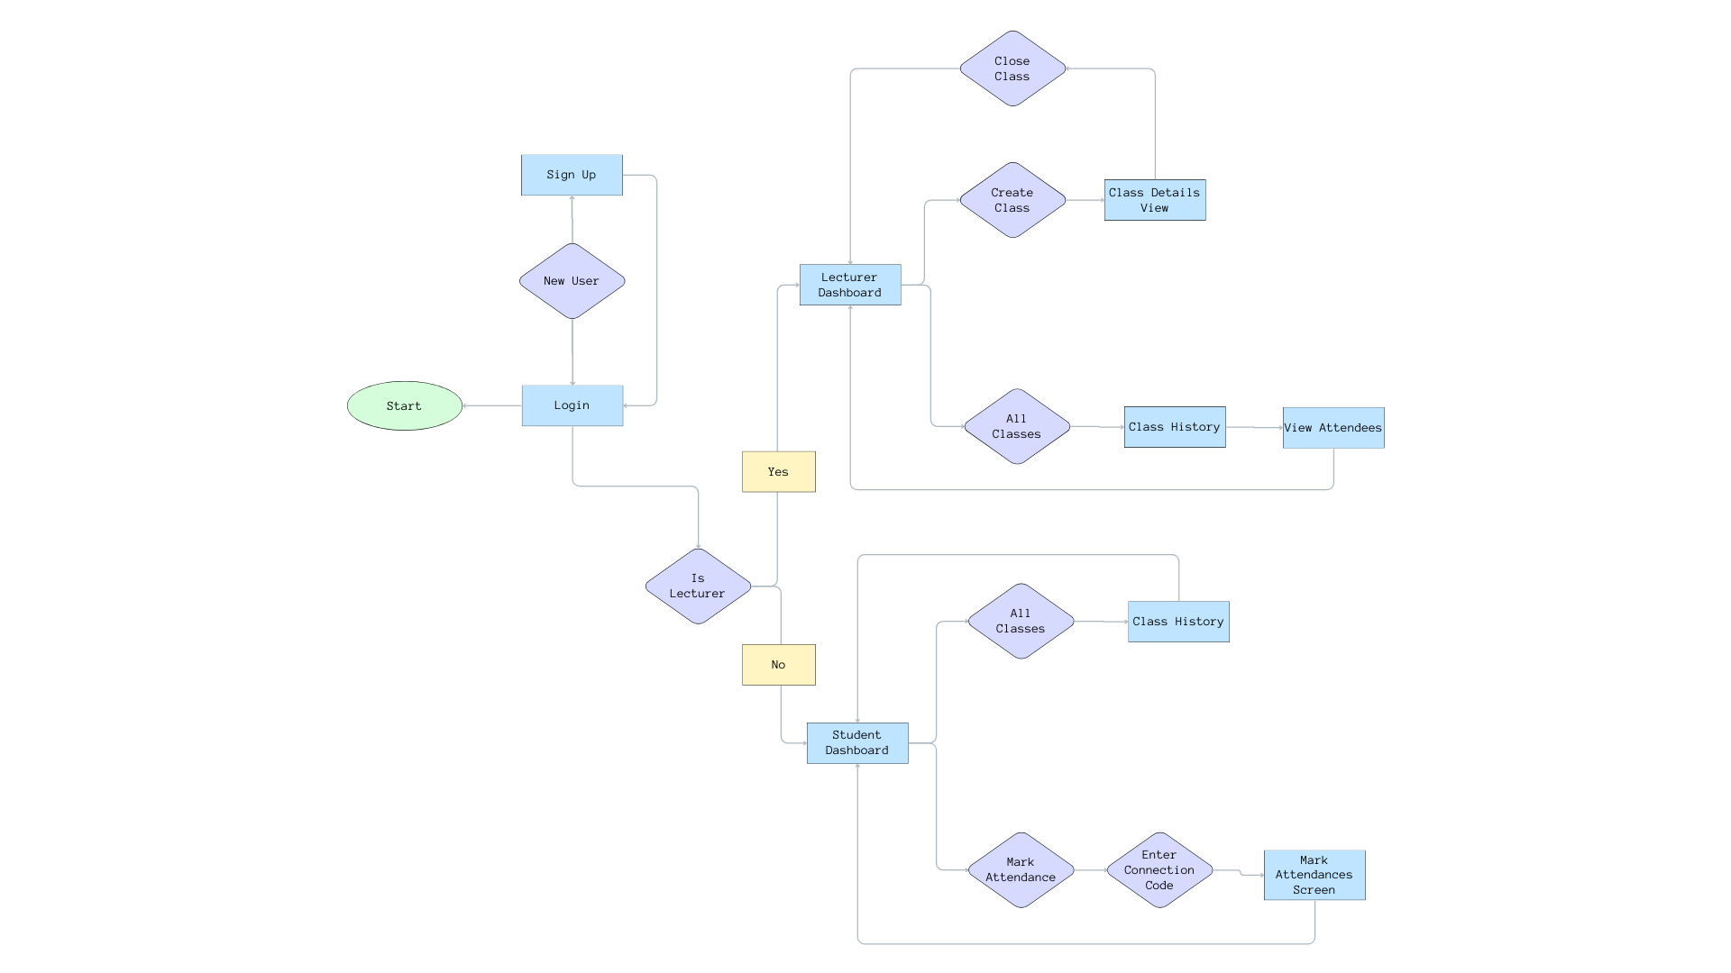

The control flow graph illustrates the flow of operations and interactions within the mobile app developed for the smart sensor attendance system. The graph provides a visual representation of how users (lecturers and students) navigate through different screens and perform various actions within the app.

Starting from the login and signup screens, users can authenticate themselves and access their respective dashboards. Lecturers are directed to the lecturer dashboard, where they can view previously created classes and create new classes by generating unique attendance codes. Students, on the other hand, are directed to the student dashboard, where they have the option to mark their attendance and view their attendance history.

The control flow graph shows the branching paths within the app, enabling users to perform different actions based on their roles and privileges. Lecturers can navigate to the class details screen, where they can view attendance records, manage class information, or generate attendance reports. Students can mark their attendance by scanning the Bluetooth beacon signal, which triggers the proximity-based algorithm for distance estimation.

**4.2 INTEGRATION OF IOT, BLUETOOTH BEACON TECHNOLOGY AND FLUTTER IN BUILDING THE MOBILE APP**

Internet of Things (IoT) connectivity allows real-world objects like BLE beacons to generate data and communicate it over the internet. The beacons serve as IoT devices, broadcasting identifying signals.

Bluetooth Low Energy (BLE) beacon technology enables these small wireless transmitters to broadcast identifier signals using very low power. This allows for proximity detection via mobile devices.

Flutter has embedded support for Bluetooth Low Energy (BLE) scanning and connectivity via the flutter_blue package. This provides access to core BLE functionality needed for beacon detection. When building the attendance app, flutter_blue was imported and initialized to start BLE scanning. The startScan() method scans for nearby BLE devices. Once BLE beacons are detected, their broadcast identifier and signal strength can be extracted from the scanned results using the flutter_blue APIs. Flutter's stateful widget architecture makes it easy to update the UI when a new beacon is detected. This can show the beacon ID prominently for checking attendance. For UI, Flutter's declarative widget-based framework helps quickly build an attractive, easy to use interface for students to access attendance data. Flutter's native compilation helped obtain smooth performance for BLE scanning, which occurs efficiently in the background. In summary, Flutter enables building a high-quality app that seamlessly integrates with IoT BLE beacons to detect proximity and record attendance data for cloud syncing.

Internet of Things and Bluetooth Beacons

- IoT allows ordinary physical objects to have network connectivity and generate data.

- Bluetooth Low Energy Beacons serve as simple IoT devices that broadcast identifier signals.

- The compact beacons are powered by batteries and can run for years.

- BLE signals contain a unique ID detectable within a range of approximately 50 meters.

- Beacons can be deployed in classrooms to create proximity zones for attendance.

- Mobile apps can detect these signals for location-aware experiences.

Flutter App Development

- Flutter SDK enables building high-quality native iOS and Android apps using Dart.

- Flutter provides ready-made widgets, tools, and libraries to build UI and logic.

- Hot Reload makes iterating and testing business logic very fast.

- Dart language and core framework help focus on app functionality vs. platform details.

- Native compilation ensures excellent performance, like smooth 60 fps animations.

Beacon Integration

- Flutter has embedded support for BLE via the flutter_blue package.

- flutter_blue plugin exposes APIs for scanning, connecting, and interacting with beacons.

- Start and stop scan functions allow detecting nearby beacons efficiently.

- Beacon data like identifiers, RSSI, and telemetry can be extracted from scans.

- App architecture uses Riverpod for reactive state management.

- Scanned beacons are stored in local storage or synced to cloud databases.

**4.3 CHALLENGES FACED DURING DEVELOPMENT**

The development of a robust and scalable smart attendance system using emerging technologies like Bluetooth Low Energy beacons, cloud databases, and mobile apps requires overcoming several technical challenges. Some key challenges include addressing the problem of Android background processes being restricted, devices being unable to see BLE, and catering to intermittent network connectivity.

**4.3.1 BACKGROUND PROCESSES RESTRICTION**

If a device is in power saving mode, the background process set in place to update the timestamp to the cloud storage might be terminated, and sometimes it can be terminated by Android for no reason at all.

This is a problem as the student attendance will not be correctly represented by the system. This is combated by the creation of an interface dedicated to checking if the attendance is up to date, this interface has a button which when pressed checks if the background process has been stopped and restarts it correctly updating the attendance as it does. And if the app is kept in the foreground, the button’s functionality is run automatically eliminating the need for manual pressing but keeping the phone screen on can be battery intensive so checking the device every 15 minutes for the timestamp update notification and tapping the button when it is not received. The interface for checking the attendance status also contains information to help the user realize if the attendance has not been going on and for how long.

**4.3.2 DEVICES UNABLE TO SEE BLE**

One of the challenges faced during development was cases where student devices were unable to detect BLE beacons, preventing attendance marking. To address this, the team implemented an in-app diagnostics screen dedicated to testing BLE visibility.

This diagnostics screen guides users through initiating a BLE scan and searching for the classroom beacon specifically. A timeout countdown is shown while scanning. If the expected beacon is not detected within the timeframe, the screen prominently displays an error message indicating the device cannot see BLE signals.

The messaging informs users that the issue lies with their device's Bluetooth connectivity rather than the venue's beacon infrastructure. It provides basic troubleshooting instructions such as checking the Bluetooth settings, updating their operating system version, or contacting technical support for advanced issues.

By isolating the fault to devices that cannot scan BLE reliably, this solution shifts the user's focus to resolving problems with their smartphones.

**4.3.3 INTERMITTENT NETWORK CONNECTIVITY**

Unreliable network connections, whether WiFi or cellular data, pose a challenge for the attendance system by disrupting the synchronization of scanned beacon data to the cloud database. When a student's device goes offline fully or faces temporary loss of connectivity, it cannot reliably upload the attendance logs containing the classroom beacon IDs detected and timestamps. This leads to gaps in the beacon records utilized by the system to mark classroom presence, resulting in inaccurate attendance information.

To identify scenarios where spotty or poor network connectivity from a student's mobile device may impact the attendance logs, the app implements background monitoring of connectivity metrics like latency and bandwidth. When these metrics breach pre-defined thresholds that characterize unreliable connectivity, the app triggers a notification to alert the user. The notification informs the student that network connectivity issues have been detected on their device which could potentially affect attendance marking accuracy. It advises them to switch to a stable WiFi network or move closer to the access point to improve connectivity. By periodically rechecking the metrics, the app can clear the alert when network conditions improve again.

This in-app notification provides visibility to students when their device's network connection is too intermittent to reliably sync beacon logs. They can take proactive measures like finding a better WiFi spot to improve connectivity. Meanwhile, the app continues to retry cloud synchronization of logs whenever possible. By monitoring and alerting on connectivity, the system is made more robust to real-world network instability.

**4.4 STEP BY STEP IMPLEMENTATION OF THE SYSTEM**

The development of the end-to-end smart attendance system using BLE beacon technology required carefully planned phases for rolling out the various components. A step-wise implementation approach was followed, beginning with the foundational infrastructure and progressively building upon it with the application logic and user interfaces. The process commenced with the installation and configuration of the Bluetooth Low Energy beacons within classrooms for proximity detection. The cloud storage and authentication was then setup with firebase. With the core infrastructure in place, the focus shifted to developing the cross-platform mobile application, integrating BLE scanning features into the app. Each stage of the implementation was thoroughly tested before moving to the next phase.

**4.4.1 CONFIGURING AND INSTALLING THE BLUETOOTH LOW ENERGY BEACONS**

The initial phase focused on procuring, configuring and installing the Bluetooth Low Energy (BLE) beacons across classrooms, auditoriums and discussion rooms. The hardware team researched a variety of beacon models based on the desired battery life, broadcast range, and ruggedness. The beacons were selected for their durable construction and replaceable batteries. The beacons were configured to encode using Eddystone UID frame types which broadcast unique identifiers optimized for proximity detection use cases.

**4.4.2 PROVISIONING AND DEVELOPING THE FIREBASE CLOUD INFRASTRUCTURE**

Concurrently, the back-end team provisioned the Firebase Cloud Firestore database that provides a flexible, scalable JSON document store to act as the central data repository. The free tier was used during development, with plans to scale up instance types prior to production use at scale. Database authentication was also set up. Granular access controls implemented as security rules ensured data partitioning between classes and controlled read-write authorization.

**4.4.3 MOBILE APPLICATION DEVELOPMENT**

With the beacon and cloud infrastructure in place, the team's focus shifted to building the mobile application for students and teachers. The app would serve as the front-end for scanning beacons and visualizing attendance data.

* Choosing tech stack: Flutter was selected since it offered portable Dart-based development and high-performance native UI rendering. For the user interface design, wireframes were created focusing on simplicity and visual appeal. Flutter's widget-based framework enables quickly iterating on the UI.
* Design UI/UX: This was accomplished with the web based tool called figma. Figma provides a lot of tools to create and design ui and it was used to develop visually pleasing designs for the app.
* Implement core UI: Flutter framework was used to build out the main app screens like login, home and signup screens.
* BLE features: Integration with beacons was a priority. The flutter_blue package provided access to native BLE scanning APIs for detecting nearby beacons efficiently in the background. There was no need for storing the results since the distance needed to be calculated from the current RSSI and transmit power values.
* Incorporate authentication: Login and signup features were also implemented. The login requests the user’s email and password while the signup requests the students to input their matric number along with other details.
* Develop attendance view: Creation of screens related to attendances including views to create attendance, close attendance, mark attendance e.t.c
* Firebase Integration: This was achieved with the use of firebase auth, firebase core and firebase cloud storage plugins. They are used for authentication, base features and cloud storage of attendances respectively.
* Unit Testing: Unit testing was performed on individual components of the system, including the mobile app, proximity-based algorithm, and integration with Firebase. This testing verified the functionality of each component in isolation, ensuring that they perform as expected . Unit tests will cover various use cases and scenarios to validate the behavior and correctness of the components.
* Integration Testing: Integration testing focused on verifying the interoperability and seamless communication between different modules and components of the system. This testing ensures that all components work together harmoniously and exchange data accurately. Integration tests will cover scenarios such as data flow between the mobile app, proximity-based algorithm, and Firebase integration. By conducting integration testing, any compatibility issues, data inconsistencies, or communication errors was identified and resolved.

**4.5 DETAILED DESCRIPTION OF THE DEVELOPED SYSTEM**

The developed system consists of a mobile app built using the Flutter framework, designed to run on Android platform. The mobile app provides separate interfaces for lecturers and students, allowing them to access attendance-related functionalities. The app leverages Bluetooth technology to detect and communicate with Bluetooth beacons (specifically the NRF51822 model) strategically placed in classrooms.

The mobile app utilizes the Flutter Blue package to scan for nearby Bluetooth devices and retrieve the received signal strength indicator (RSSI) values from the Bluetooth beacons. The proximity-based algorithm, incorporating the log-distance path loss formula, is implemented within the mobile app to estimate the distance between the user's device and the Bluetooth beacon based on the RSSI values. This distance estimation is used to determine whether the user's device is within the defined range for attendance marking.

The Flutter app initial page is the login page, there is a button on said page to the sign-up page. The user is expected to login and if not sign-up instead. A web portal will be given to the appropriate school authority through which lecturers can sign up with while the sign-up screen in the app is only for the students so as to prevent students from trying to access the lecturer’s dashboard.

The sign up process involves the user’s email and password and then the user's details are saved to Firebase Firestore. After the login credentials is verified then the user is taken to their respective dashboard depending on if they are a lecturer or student and that is confirmed from their data existing in Firebase Firestore. For the student, the dashboard provides a button to mark attendance, when the button is pressed, the user is prompted to input the connection code for the class to be attended and if the class exists and the class is open, the student can choose to mark attendance.

When the lecturer creates a class, the lecturer can choose to close the class at any point in time or allow the class to close automatically by defining a closing time. When a class is closed, the attendance is iterated through and any student that falls short of the minimum attendance time predefined by the lecturer is deleted from the attendance list. On the student side, the app checks the connection to the beacon every 10 minutes and updates the attendance time accordingly.

An attendance is approved if the student distance falls inside the range predefined by the lecturer and the student present time is equal or above the time set by the lecturer.

On the server side, Firebase provides the necessary back-end infrastructure, including user authentication, data storage, and real-time data synchronization. Firebase's APIs and SDKs are leveraged within the Flutter app to establish a connection with Firebase services and securely transmit attendance data. The attendance is stored in a collection called class under the field attendees which contains a map of attendee id and timestamp which represent the amount of time in minutes that the student has been in class.

The backend infrastructure relies on Firebase as the cloud storage and synchronization platform. It is integrated into the mobile app, allowing attendance records to be securely stored and accessed by lecturers. Firebase Authentication ensures secure user login and access control, while Firebase Firestore enables real-time data synchronization between the mobile app and the cloud storage.

**4.6 USER INTERFACE AND FUNCTIONALITIES**

The user interface (UI) of the attendance management system aims to provide an efficient, user-friendly experience catered to the respective needs of students and teachers. A key objective is minimizing the steps required to execute common attendance workflows through thoughtful UI design. The mobile application prioritizes a simple, focused interface allowing students to check-in and review their attendance status seamlessly and lecturers to create classes and view attendees..

**FIG 1.2 SCREENSHOT OF LOGIN AND SIGN-UP PAGES**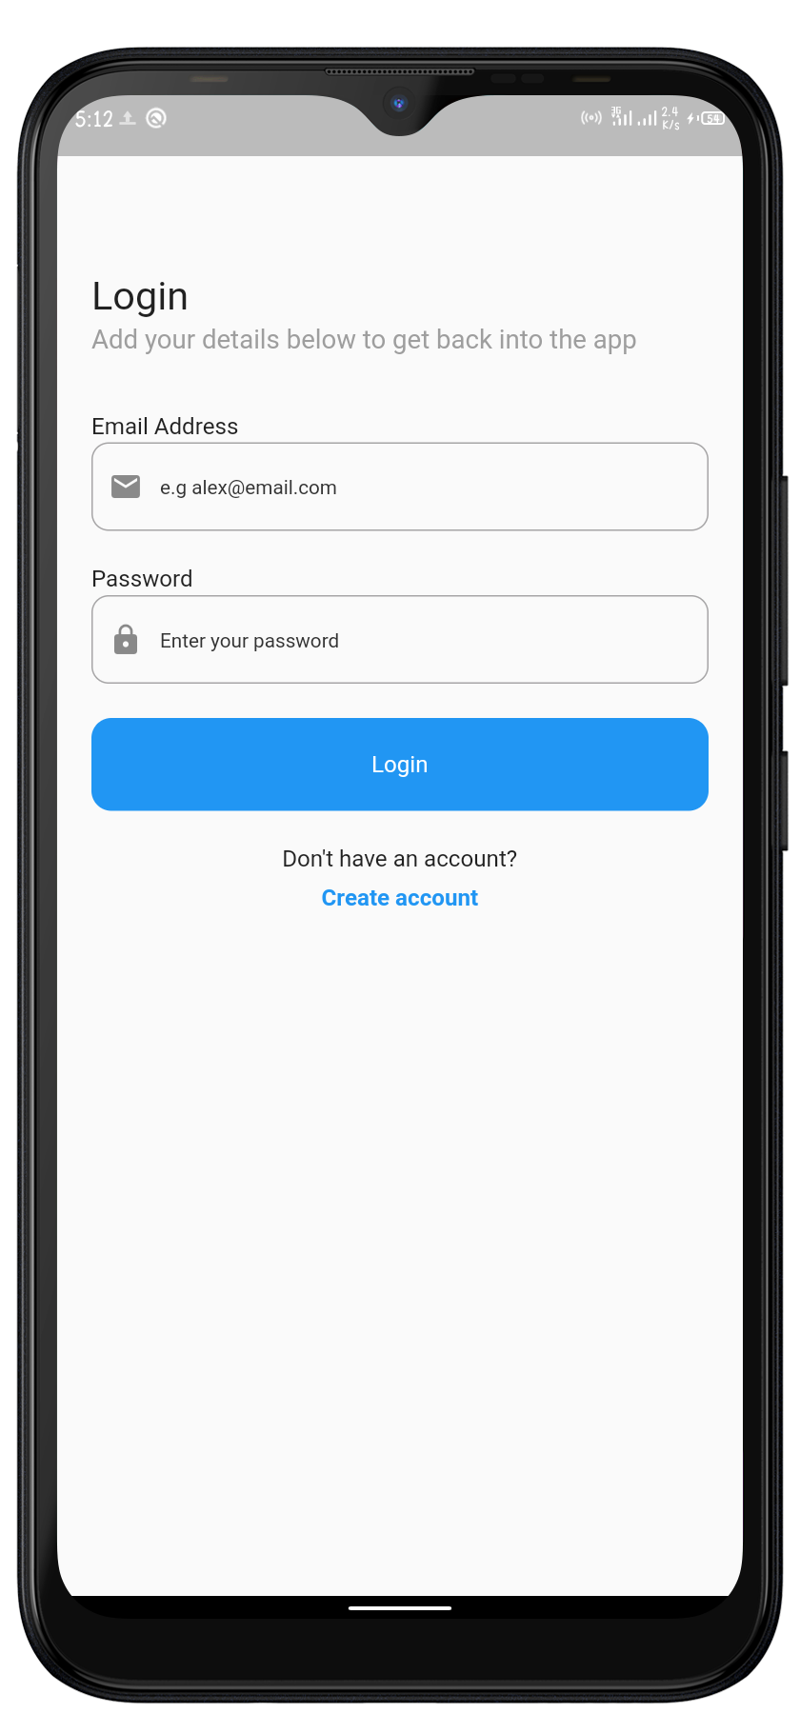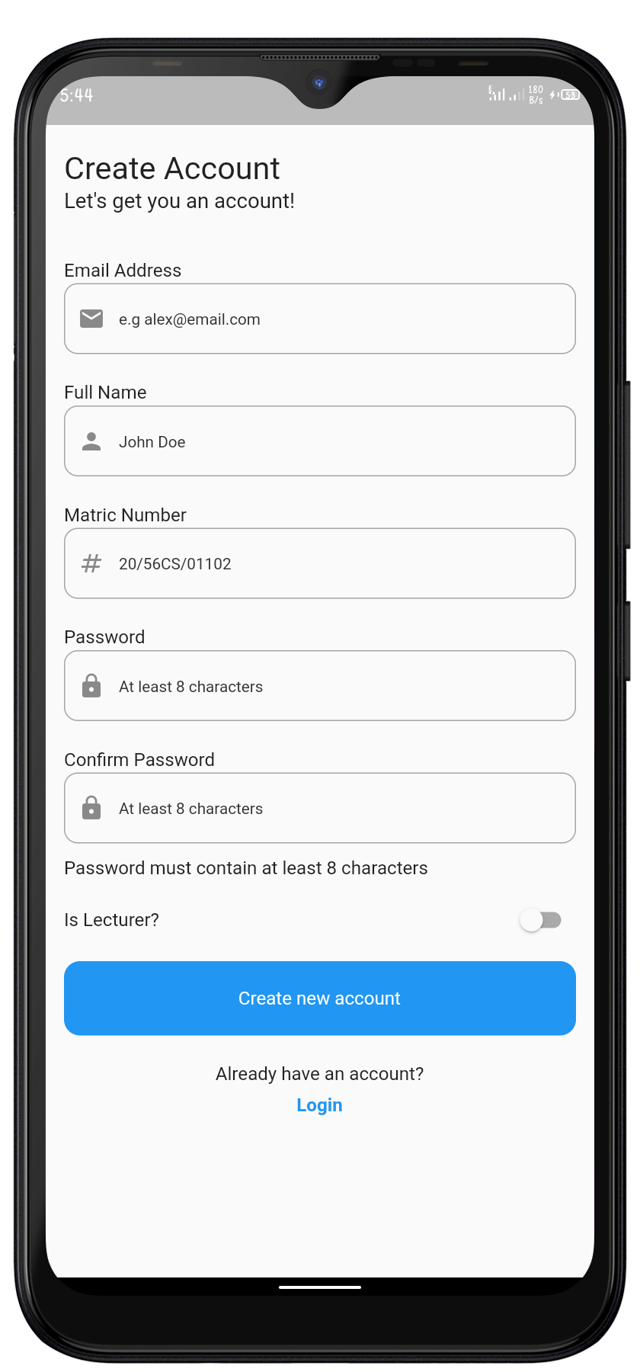

Enabling secure user access is a core requirement for the attendance system. To support this, dedicated login and sign-up pages were implemented as part of the mobile application.

Fig 1.2 shows the login page’s simple yet elegant interface for students to authenticate using their email and password. Input validation ensures only properly formatted emails and passwords are allowed. The credentials are securely transmitted over HTTPS to firebase. Upon successful authentication, the main app interface is displayed.

For new users, a sign-up page is provided to create their user account. Following material Design principles, this page presents registration fields in a clean, intuitive layout. Client-side validation provides immediate error feedback for incomplete or invalid inputs. After server-side validation, new user details are stored securely in firebase.

Both pages employ responsive design to optimize the interface across different mobile form factors. By handling access management gracefully, the login and signup pages allow providing students a seamless yet secure means to use the attendance system. During testing, users found both flows to be simple, quick and visually appealing.

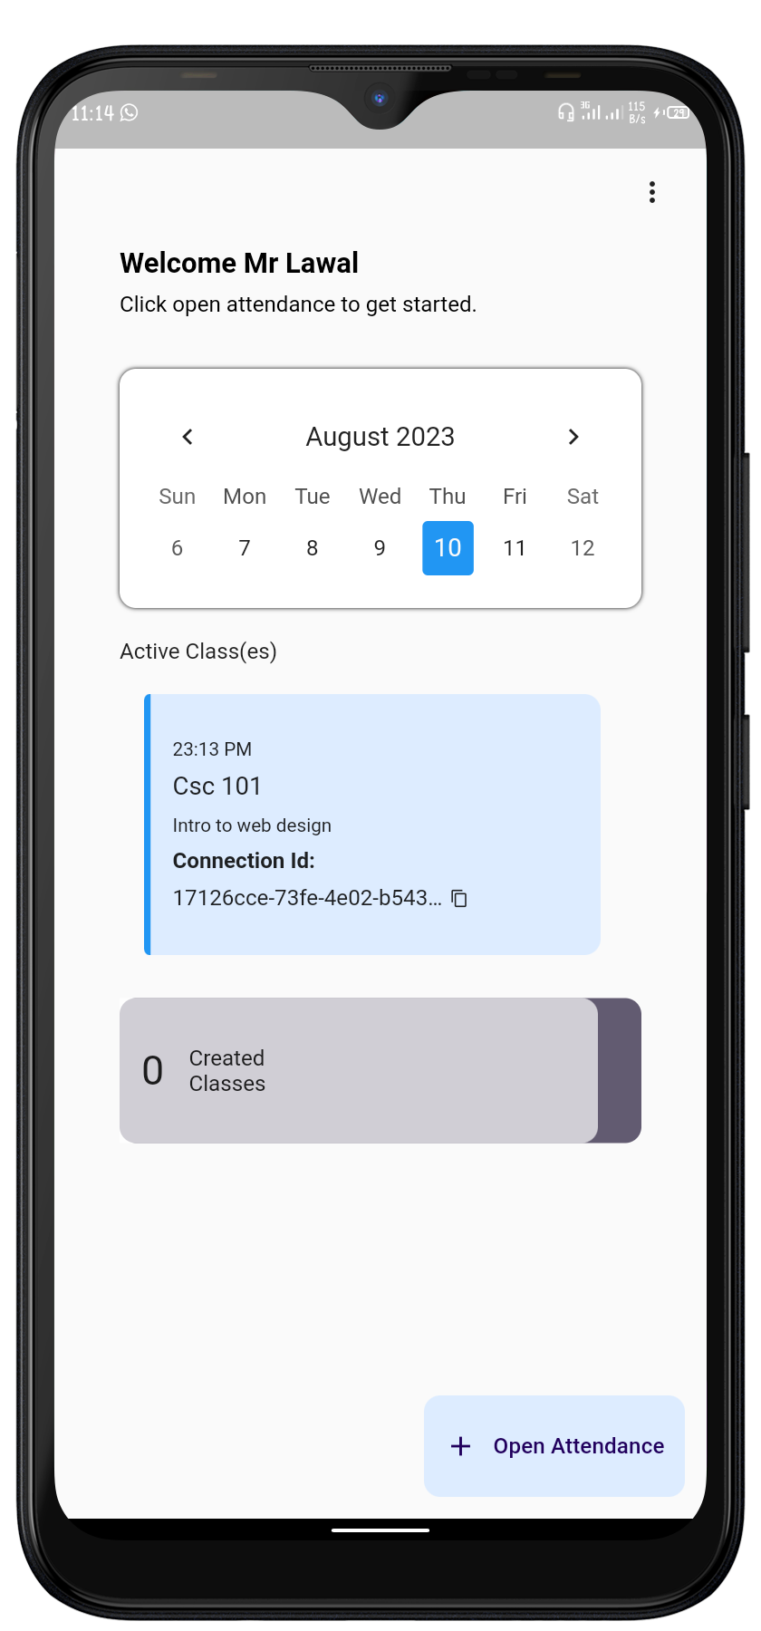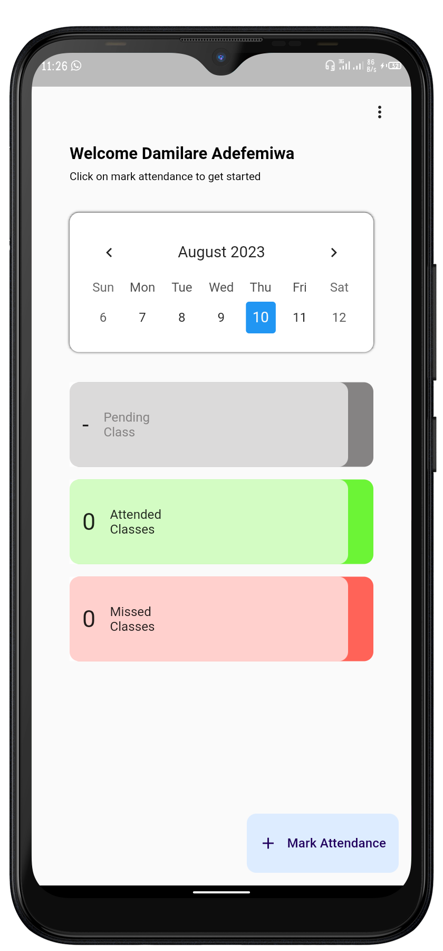

**FIG 1.3 SCREENSHOT OF LECTURER DASHBOARD AND STUDENT DASHBOARD**

Fig 1.3 shows the home dashboards presented in the mobile application enable students and teachers to conveniently access the core functions related to their workflows.

For students, their dashboard page displays a button to see all previous attendances and also if there is an ongoing attendance. There is also a button for marking attendance which presents a dialog box that allows the input of the class’ connection code.

On the teachers' dashboard, a floating action button to create a class is available to the lecturers. There is a button to access the previous attendances also.

**FIG 1.3 STUDENT MARK ATTENDANCE SCREEN**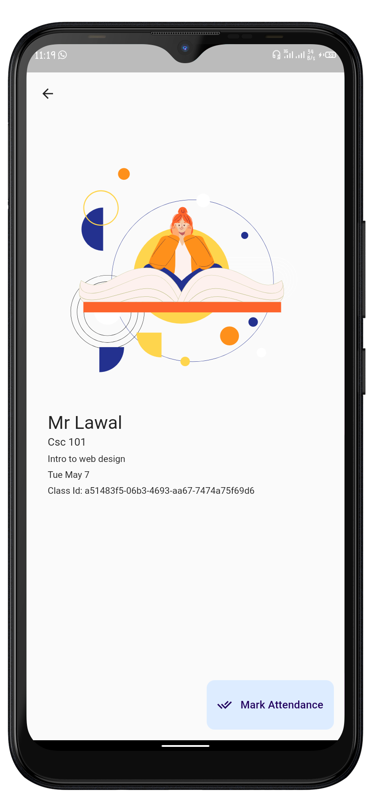

Fig 1.3 shows the screen that comes up after the students input a valid connection code. The screen shows the lecturer’s name, the course code and the course title. The screen allows the student to validate the class to be attended by confirming the class details and then proceed to clicking the floating action button that initiates the marking of the attendance.

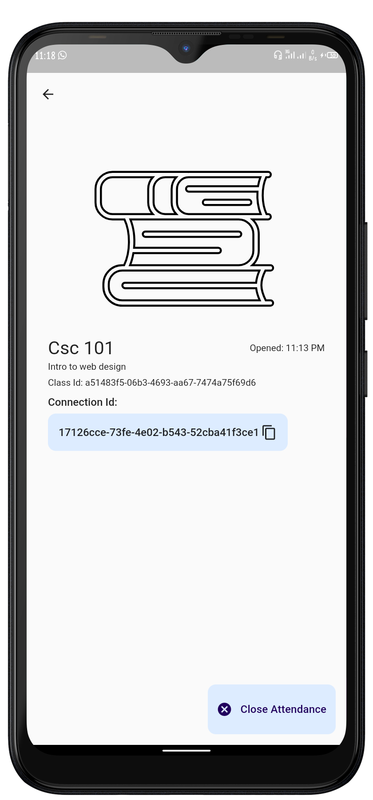

**FIG 1.4 LECTURER CLOSE ATTENDANCE SCREEN**

Fig 1.4 shows the screen shown to the lecturer when an active class is selected. It offers the option of closing the class to attendances so no student can join the attendees or increase their attendance time. When the button is pressed, the list of attendees is iterated through and any student with a timestamp lower than three quarters of the class’ duration is deleted as they failed the attendance criteria which requires at least three quarters of the total class time.

**4.7 OTHER RELATED STUDIES**

A review of existing literature reveals various prior studies and proposed systems related to automating student attendance tracking. RFID-based systems have been extensively researched which utilize RFID cards and readers for proximity detection. Biometrics-driven approaches using fingerprint or facial recognition have also been explored. Bluetooth Low Energy (BLE) beacon technology has more recently emerged as a promising option for automated attendance, with different implementations demonstrating the feasibility of this approach. However, additional opportunities remain to build on these previous studies through a robust and user-friendly implementation leveraging BLE beacon infrastructure, cloud platforms, and mobile technology. This project aims to develop such an integrated system to deliver automated yet flexible real-time attendance tracking for enhanced classroom management.

**4.7.1 COMPUTERIZED ATTENDANCE SYSTEM**

In V.V.Nagar, Gujarat International Journal of Advance Research in Computer Science and Management Studies we realized that while both systems aim to digitize attendance tracking, our BLE beacon approach is more passive, scalable and preserves privacy compared to their biometric scanning proposals. Some key differences between the BLE beacon based attendance system we have been discussing and the RFID/face recognition system proposed in this review paper.

In terms of technological approaches, there are distinct differences between our system and the proposal outlined in the referenced work. Our system employs Bluetooth Low Energy (BLE) beacons as a central component, while the proposed system introduces the use of both RFID technology and facial recognition for attendance management.

Our system's architecture encompasses a comprehensive blend of BLE beacons, mobile applications, and a cloud-based backend infrastructure. In contrast, the proposed system primarily revolves around biometric technologies. Our approach enables passive attendance marking through beacon detection, wherein students' presence is automatically recorded upon entering the vicinity of the beacon's signal. Conversely, the proposed system relies on active biometric scans, requiring students' direct involvement in the attendance process.

One of the distinguishing features of our system is its flexibility in allowing students to mark their attendance using their personal mobile devices. In contrast, the proposed system utilizes dedicated biometric scanners operated by teachers for attendance recording.

Furthermore, our BLE beacons are characterized by their simplicity and cost-effectiveness. This is in contrast to biometric scanners, which tend to be more complex and expensive to implement.

In terms of backend functionality, our system incorporates an automated attendance calculation feature, streamlining the calculation process for educators. However, the referenced paper does not provide explicit details regarding the implementation of automated attendance calculations within their proposed system.

Addressing privacy considerations, our system places significant emphasis on preserving student privacy. This stands in contrast to the proposed biometric approach, which raises concerns regarding the potential intrusion into students' biometric data and personal information.

We also studied Eid Al Hajri et al Fully Automated Classroom Attendance System and both systems digitize attendance but our approach better leverages mobile and BLE tech and is less complex compared to their RFID/biometrics focused system. The primary distinctions between our system and the proposed alternative lie in the following areas:

Firstly, our system takes advantage of Bluetooth Low Energy (BLE) beacons, while their proposal revolves around the utilization of RFID cards and biometric authentication methods. This fundamental technological choice sets the tone for the overall approach to attendance management.

Architecturally, our system incorporates a synergy of BLE beacons, mobile applications, and cloud-based backend infrastructure. In contrast, their approach combines smart cards and mobile applications. Our design offers a comprehensive solution involving diverse components that work cohesively to optimize the attendance process, while their focus centers on the integration of smart cards and app-based functionalities.

One of the most noteworthy differences lies in the method of attendance marking. Our architecture enables passive attendance recording through beacon detection, a process that requires no explicit action from students. Conversely, their proposal necessitates active RFID scans and biometric authentication, demanding direct involvement from students to mark their attendance.

Moreover, our system empowers students to conveniently mark their attendance using their own mobile devices. This stands in contrast to their approach, which requires the availability of dedicated RFID readers and the utilization of specific apps for attendance tracking.

Cost, simplicity, and infrastructure requirements are significant points of divergence. Our BLE beacons are cost-effective, straightforward, and battery-powered devices that seamlessly integrate into existing infrastructure. In contrast, their solution relies on smart cards and biometrics, necessitating a more intricate infrastructure setup.

In terms of privacy considerations, our system demonstrates lower privacy concerns compared to their incorporation of biometric data. This distinction is crucial, especially in educational settings where safeguarding student privacy is of paramount importance.

**4.7.2 MOBILE APP BASED ATTENDANCE**

Taking Jun Iio journal Attendance Management System Using a Mobile Device and a Web Application we realize that our system is mobile-centric leveraging BLE beacons, while theirs uses fixed RFID readers and tags. But the core attendance tracking functionality remains similar.

Our system employs Bluetooth Low Energy (BLE) beacons, in contrast to the focus on RFID technology in the referenced paper. This choice is motivated by BLE's advantages of extended range and lower power consumption. While the paper's system relies on fixed RFID readers positioned at classroom entrances, our approach utilizes mobile apps capable of scanning the beacons. This mobile app-based solution offers greater flexibility and adaptability. Additionally, our architecture features a cross-platform mobile app, unlike the paper's system, which does not mention a mobile component.

In terms of data management, our system integrates cloud databases such as Firebase, while the paper's approach appears to involve a custom web application backend. This decision allows for seamless data synchronization and accessibility across devices. Notably, our system introduces the option of registering attendance through selfies or digital signatures, providing a more personalized and interactive experience for users. In contrast, the RFID-based system in the paper relies on automated scans for attendance recording.

A fundamental distinction lies in how the beacon and RFID technologies are employed. Our BLE beacons emit signals that are detected by the mobile apps, offering a user-friendly and efficient way to mark attendance. Conversely, the RFID system in the paper necessitates students physically tapping their RFID tags on readers for attendance logging. This underscores the divergence in interaction mechanisms between the two systems.

Looking at N Saparkhojayev et al Mobile Attendance Checking System on Android Platform for Kazakhstani University we realized that while both apps aim to digitize attendance, our architecture focuses more on automated detection using BLE beacons and cloud processing, while their app uses manual student identification on the teacher's device. We were able to elicitate the following similarities and differences between our app and the Android app system described in this conference paper:

In terms of similarities, both systems share the common goal of automating attendance tracking through the use of mobile devices. By employing modern technological solutions, they effectively eliminate the need for traditional paper-based attendance methods. In both systems, students are electronically identified and marked as present, leveraging the convenience of mobile technology to streamline the attendance process. The overarching aim of these similarities is to provide efficiency and time savings over conventional manual attendance-taking approaches.

However, differences emerge between the two systems in terms of their underlying technologies and functionalities. Our system utilizes Bluetooth Low Energy (BLE) beacons as a key component, while the other system focuses on direct student identification within the app. This distinction in technology results in varying methods of attendance recording.

Moreover, our architecture adopts a combination of BLE beacons, mobile apps, and cloud-based backend infrastructure to facilitate attendance management. In contrast, their system relies solely on the app for attendance tracking. A significant divergence is evident in how attendance is taken without student action: our approach achieves this via beacon detection, while their system necessitates explicit student identification within the app.

Furthermore, our system empowers students to take attendance on their own mobile devices, while the other system employs teacher smartphones passed around the classroom. Additionally, our system collects attendance data on the cloud, providing centralized storage and accessibility, whereas their app stores data locally within the app itself.

The user experience also varies: our application allows registration through selfies or digital signatures, enhancing engagement and customization. Conversely, their approach involves selecting student names for attendance recording.

Notably, our backend includes an automated attendance calculation feature, which is not mentioned in the paper. This showcases our system's commitment to further automation and efficiency in attendance management.

**4.8 BENEFITS AND LIMITATIONS**

Over the course of building and testing the app there are a couple of limitations that were exposed and also a lot of benefits involved in the usage of the app. Some of the benefits include:

* Ease of use: Since all the lecturer has to do is start and eventually close the attendance that makes the attendance marking easy to use. The only task that is slightly more complex is the downloading of attendees in excel format(csv) since it involves the lecturer looking for the specific class in the list of previously created classes and then downloading it.
* Student presence confirmation: In order to mark an attendance, the student needs to be physically present since the broadcast from the bluetooth beacon is required to mark the attendance and it is also required every fifteen minutes thereby making sure the students cannot just leave after starting the attendance.
* Single app for both lecturers and students: There is a single app for both lecturers and students therefore preventing the need for the lecturer to find a different application as the application can be collected from the students and vice-versa.
* Bluetooth beacon battery life: The bluetooth beacon utilizes cr2477 lithium cell battery which is known to last well over six months thereby ensuring the smooth operation of the smart attendance system for well over six months without the need to replace any parts.
* Getting attendance information: The application provides the attendance information in excel’s csv format which makes it easy to understand. The columns in the csv file includes serial number, full name and matric number which is all a lecturer needs for the class’ attendance.

During the course of developing and testing of the application, a couple of limitation have been experienced, they include:

* Reliability on internet connectivity: The application requires internet connection in order to update the backend with the current timestamp value. If there is absence of network, the user is informed but that does not help in situations where internet connection is widely unavailable.
* Battery life: In order for the attendance to be successful, the student needs their internet connection, Bluetooth and location to be switched on which in the long run consumes the mobile device's battery. If the student has a low device then the device might not be able to stay on through the duration of the class resulting in the student being marked absent even though the student was present. While efforts have been made to optimize power usage, the attendance application's reliance on Bluetooth connectivity may impact the overall battery life of user devices. This limitation may require users to be mindful of their device's battery levels or have access to charging facilities during extended periods of use.
* The need for smartphones: The application warrants the students and lecturers ownership of a smart phone which might not always be the case as some student’s smartphone might be faulty or might not have one at all.
* Distance Estimation Accuracy: Achieving accurate distance estimation based on the log-distance path loss formula involves calibration, considering environmental factors, and accounting for hardware limitations. Calibration procedures, including measuring RSSI at different distances and refining the formula parameters, helped improve accuracy.
* Real-time Synchronization: Ensuring real-time synchronization between the mobile app and the Firebase backend demanded careful handling of network connectivity issues and data conflicts. Implementing appropriate offline capabilities, leveraging Firebase's synchronization features, and employing conflict resolution strategies helped address these challenges.
* Interface Design: Designing user-friendly interfaces that accommodate both lecturers and students, with intuitive navigation and clear attendance management features.
* Bluetooth Beacon Range and Connectivity: One of the limitations of the attendance application is the range and connectivity of Bluetooth beacons. The effective range of Bluetooth beacons may vary depending on the environmental conditions, such as interference or physical barriers, which could affect the accuracy of attendance confirmation. In some cases, weak or intermittent connectivity may result in missed or delayed attendance recordings.
* User Adoption and Familiarity: The success of the attendance application relies on user adoption and their willingness to adopt new technologies. Resistance or reluctance from lecturers or students to embrace the application may hinder its effectiveness and impact the overall attendance recording process. Users who are unfamiliar with mobile apps or web interfaces may require additional training or support to fully utilize the attendance application.
* Scalability: The scalability of the attendance application may pose limitations, particularly in scenarios with a large number of concurrent users or multiple courses running simultaneously. The performance and response times of the application may be affected under high user load, potentially impacting the real-time attendance recording experience. Further optimization and infrastructure scaling may be required to address scalability challenges.
* Institutional Infrastructure and Support: The successful implementation of the attendance application relies on the availability of a reliable institutional infrastructure, including network connectivity and support services. Limitations in infrastructure resources, such as limited network bandwidth or inadequate technical support, may impact the application's performance and hinder its seamless operation.

**CHAPTER 5**

**CONCLUSION AND FUTURE WORK.**

The project "Smart Sensor Attendance Using Bluetooth Beacon and Mobile App" has successfully achieved its objectives of developing a reliable attendance tracking system and incorporating proximity-based algorithms. This chapter provides a summary of the project objectives and key findings, highlights the contributions to the field of study, and offers recommendations for future research or improvements.

Throughout the project, significant progress was made in achieving these objectives. The mobile app was successfully built using Flutter, providing separate interfaces for lecturers and students. The integration of Bluetooth beacons allowed for proximity-based attendance marking, employing the log-distance path loss formula to estimate distances based on received signal strength indicator (RSSI) values. Firebase integration ensured secure storage and retrieval of attendance data for lecturers to access and manage.

Key findings from the project highlight the feasibility and effectiveness of using Bluetooth beacons and a mobile app for attendance tracking. The proximity-based algorithm demonstrated accurate proximity detection, enabling reliable attendance marking based on the lecturer-defined range. The integration of Firebase facilitated real-time data synchronization and provided a secure storage solution for attendance records.

The project's contributions to the field of study include showcasing the potential of Bluetooth technology and mobile apps in enhancing attendance tracking systems. By combining proximity-based algorithms with modern mobile app development, the project presents an innovative solution to automate attendance management in schools. Additionally, the use of Firebase as a cloud storage and synchronization platform contributes to the advancement of attendance tracking technologies.

For future research and improvements, several recommendations can be made. Firstly, further validation and testing of the proximity-based algorithm should be conducted in diverse real-world scenarios to assess its robustness and accuracy. Additionally, user feedback should be collected and incorporated to refine the mobile app's user interfaces and enhance the overall user experience. Exploring additional features such as real-time notifications, automated reports, and integration with other educational systems would also be worthwhile.

**5.1 SUMMARY OF PROJECT OBJECTIVES AND KEY FINDINGS:**

The primary objectives of the project were to create a smart sensor attendance system using Bluetooth beacons and a mobile app, implement a proximity-based algorithm for accurate distance estimation, and leverage Flutter for app development with Firebase as the backend. Throughout the project, significant progress was made in achieving these objectives.

Key findings from the project include:

1. Successful Development of the System: The project has successfully developed a mobile app using Flutter, providing separate interfaces for lecturers and students. The integration of Bluetooth beacons and the implementation of the proximity-based algorithm allowed for accurate proximity detection and attendance marking.

2. Reliable Distance Estimation: The incorporation of the log-distance path loss formula facilitated accurate distance estimation based on the received signal strength indicator (RSSI) values. The calibrated parameters, including the reference path loss (PL(d0)) and path loss exponent (n), contributed to reliable distance estimation within the defined attendance marking range.

3. Secure Storage and Synchronization: The integration of Firebase as the backend ensured secure storage and real-time synchronization of attendance data. Lecturers could access and manage attendance records, while students could view their attendance history, all with the assurance of data privacy and reliability.

**5.2 CONTRIBUTIONS TO THE FIELD OF STUDY:**

The project has made several contributions to the field of study:

1. Advancement in Attendance Tracking Technologies: By utilizing Bluetooth technology, proximity-based algorithms, and mobile app development, the project showcases an innovative solution for automating attendance tracking in educational institutions. The integration of Firebase further enhances data management and accessibility.

2. Practical Implementation of Proximity-Based Algorithm: The successful implementation of the log-distance path loss formula and the proximity-based algorithm demonstrates its effectiveness in estimating distances and accurately marking attendance based on proximity. This practical implementation contributes to the body of knowledge in proximity-based systems.

3. Integration of Flutter and Firebase: The project demonstrates the successful integration of Flutter for cross-platform mobile app development and Firebase for cloud storage and synchronization. This combination offers a robust and scalable framework for developing attendance tracking systems and can serve as a reference for similar projects in the future.

**5.3 RECOMMENDATIONS FOR FUTURE RESEARCH OR IMPROVEMENTS:**

Based on the project outcomes, several recommendations can be made for future research or improvements:

1. Further Validation and Testing: Conduct comprehensive validation and testing of the system in diverse real-world scenarios to assess its accuracy and robustness. Consider different environmental conditions, beacon placements, and user scenarios to ensure reliable performance.

2. User Experience Enhancements: Collect user feedback and incorporate it into the mobile app's interface and functionality. Continuously refine the user experience to make the app more intuitive, user-friendly, and efficient in managing attendance.

3. Exploration of Additional Features: Investigate the inclusion of additional features such as real-time notifications, automated attendance reports, and integration with other educational systems. These enhancements can further streamline the attendance tracking process and improve overall system efficiency.

4. Integration with Student Information Systems: Explore integration possibilities with existing student information systems used in educational institutions. This integration would facilitate seamless data exchange and provide a holistic view of student attendance and academic records.

5. Extended Applications: Consider extending the application of the proximity-based system to other domains where accurate proximity detection and attendance tracking are valuable, such as conferences, seminars, or large-scale events.

By addressing these recommendations, future research and improvements can enhance the functionality, accuracy, and user experience of the smart sensor attendance system. Continual advancements in proximity-based algorithms, user interface design, and integration capabilities will contribute to the evolution of attendance tracking technologies.

In conclusion, the project has successfully developed and implemented a smart sensor attendance system using Bluetooth beacons and a mobile app. The project's objectives have been achieved, and key findings demonstrate the effectiveness of the proximity-based algorithm and the benefits of Flutter and Firebase integration. The contributions to the field of study provide valuable insights into proximity-based attendance tracking systems. Future research and improvements can build upon these findings to further enhance attendance tracking technologies in educational settings and beyond.

**References**

Azmi, N. A., Shamsuddin, M. N., Hasan, R., Shamsuddin, A. M., & Ghazali, N. H. N. (2018). An Automated Attendance Management System Using Biometrics: Face Recognition. In 2018 7th International Conference on Computer and Communication Engineering (ICCCE) (pp. 70-75). IEEE.

Baharin, H. A., Ghazali, M. R., & Ghazali, R. (2020). Beacon Technology and its Applications: A Review. IEEE Access, 8, 16765-16778.

Bhalla, S., Goyal, R., Kumar, A., Jain, S., & Srinivasan, S. (2013). Attendance System Based on RFID and Bluetooth. In 2013 IEEE International Conference on Advanced Networks and Telecommuncations Systems (ANTS) (pp. 1-5). IEEE.

Jung, J., Han, G., Park, J., & Yang, J. (2019). A smart classroom service model using BLE beacons. Mobile Information Systems, 2019, 1-9.

Kwon, O. S., Hong, J. K., & Kwon, D. S. (2020). Development of a smart classroom using IoT-based BLE beacons. Electronics, 9(3), 459.

Lee, S. Y., Kim, Y., & Oh, H. J. (2021). The development of a personalized learner attendance tracking system using BLE beacon technology. Sustainability, 13(2), 592.

Li, J., Liu, H., Zhang, C., Xie, G., & Wang, X. (2019). Design and implementation of smart classroom attendance system based on Bluetooth beacon technology. Journal of Physics: Conference Series, 1180(3), 032071.

Li, T. H., & Hsu, P. F. (2020). Applying Firebase Realtime Database on a Transportation Management System for Logistics. In Proceedings of the 2020 11th International Conference on Dependable Systems, Services and Technologies (DESSERT) (pp. 230-235). IEEE.

Lodha, M., Meena, M. L., & Meena, M. P. (2015). An effective RFID based student attendance tracking system. In 2015 International Conference on Green Computing and Internet of Things (ICGCIoT) (pp. 826-830). IEEE.

Puckdeevongs, N., Khemapech, N., & Waisara, K. (2020). An IoT-based automatic classroom attendance system using BLE beacon and Wi-Fi. In 2020 16th International Conference on Electrical Engineering/Electronics, Computer, Telecommunications and Information Technology (ECTI-CON) (pp. 193-198). IEEE.

Rjeib, S. A. (2018). Design of a Bluetooth Low Energy Based Student Attendance Recording System. In 2018 13th International Conference on Computer Engineering and Systems (ICCES) (pp. 182-186). IEEE.

Saraswat, V., & Garg, S. (2016). Beacon Technology: A Smart Approach for Higher Education Institutions. International Journal of Advanced Research in Computer Science and Software Engineering, 6(12), 269-275.

Sharma, R., Singh, J., & Kapoor, A. (2020). Smart Attendance Management System using BLE and IoT. In 2020 6th International Conference on Advanced Computing and Communication Systems (ICACCS) (pp. 1264-1269). IEEE.

Smith, B., Lovan, K., & Smith, P. (2018). Student Attendance Tracking: The Role of Attendance Policies and a Brief Review of the Literature. Journal of Education and Learning, 7(4), 115-123.

Thompson, D. R., Kaptoge, S., White, I. R., Wood, A. M., Perry, P. L., Danesh, J., & International Prospective Register of Systematic Reviews (PROSPERO). (2016). Statistical methods for the time-to-event analysis of individual participant data from multiple epidemiological studies. International Journal of Epidemiology, 45(3), 973-979.